(Approx. 1,170 words)

The Running of the Nerds 2014
Lou Torraca, President, MOAA – The TUG, Hawaii
Af06hi (at) gmail.com



Who needs Barcelona and the bulls when we have Las Vegas and the Nerds? Yup, The International Consumer Electronics Show kicked off in Vegas 7-10 January with 150,000 folks running with the Nerds, wanting to see as many of the 3,200 exhibits as possible. For the media, the show starts with 3 events, CES Unveiled on Sunday night at the Mandalay Bay, Digital Experience at the Mirage on Monday night and Showstoppers at the Wynn on Tuesday night. Monday is an all-day extravaganza of press conferences, each one an hour and fifteen minutes, then a fifteen minute break to run to the next one. I also went to one that previewed the China information technology expo (CITE) sponsored by the government in April and another one that previewed IFA, held in Berlin in September and which they bill as the world's leading trade show for consumer electronics and home appliances. So, with all that said, how do u get to see anything? Fortunately, the first three events take place in ballrooms and as many as 200 vendors display their best products, which, BTW, include cars, which look like the next Tech Hot spot!



From streaming music to BING search to self-parking there was a lot of buzz about all the various models displayed. TVs were also a big hit with UHD, and curved screens causing a lot of oohs and aahs… biggest was when, with the push of a button, the curved screen was returned to a flat screen. But be prepared for sticker shock…

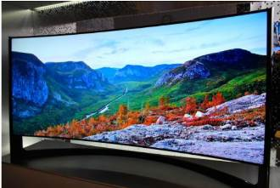

...an LG 84inch UHD is priced at $17,000. !!!!!

OK, back to the real world, here are a few gadgets that caught my eye.



DISH Super Joey
The eight-show system involves Dish's Hopper (pronounced Happah by folks from Boston or who went to BU J) DVR and a new Super Joey add-on box for separate rooms. The catch is that four of those shows have to be from the broadcast networks ABC, NBC, CBS and Fox. Dish also unveiled Joey boxes that can run wirelessly with the help of a router that sits next to the Hopper. Previously, Joey boxes had to be connected by separate coaxial cables. Now they just need power outlets. Improvements in Wi-Fi technology made the new wireless setup possible.

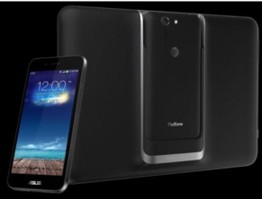

ASUS PadFoneX: Combines a smartphone with the convenience of a tablet
Easily dock the smartphone into the tablet docking station and u have a full tablet with all of your files and customizations in one place. U can charge the smartphone wirelessly or while docked for extended battery life. 4 U Techno nerds, this ASUS Padfone X device powers with 300~2266mHz MSM8974AB and Adreno 330 chipset. Other specs include 1920×1200 resolution, 2GB RAM, 16GB ROM and it will run Android 4.4 OS. Very impressive!

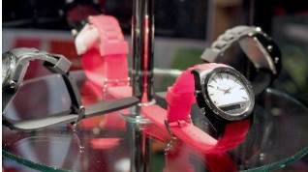

The Martian Notifier
It doesn't advertise to the world that it's a tech gadget. On the contrary, it looks almost completely like a regular watch, save for a small horizontal screen on its face. That's where you see those notifications, which have replaced voice control as the newer model's bread and butter. It lets you customize your own vibration patterns for each different type of notification. So, if you have your arms full, the pattern of vibrations you feel will let you know right away what kind of notification just came in. Just an email... no rush. That's a text... might be the one you're waiting for. You customize the patterns for each type of alert and instantly know what type of notification is coming in without looking at the watch. Smartwatches in general keep you from having to look at your phone so often - but the Martian takes that a step further and keeps you from even having to look at your watch so often. If u have one or have a friend with one… u no what I mean.

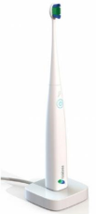

Kolibree Smart Toothbrush
Toothbrushes have joined smartphones, smartwatches and smart beds in the ranks of devices with artificial intelligence, NBC News reported.

Kolibree has introduced what they are calling "the world's first connected electric toothbrush.” The smart toothbrush senses how long and how well the user brushes and tracks down the user's performance on their phone. Besides tracking down tooth brushing performance, the electric toothbrush also teaches users how to brush right and it also tracks brushing habits.

The gadget comes with a mobile app compatible with iOS and the Android operating system that connects with the toothbrush via a Bluetooth connection. When the brush is in use, it syncs to the smartphone sharing information on how it's being used to the mobile app. Users can then share that information with their dentist, friends, family, or anyone else they choose. They can even post their results on social media. Somehow I can’t see any of my grandkids/greatgrandkids posting their brushing info on Facebook… but who knows!! On the other hand, parents trying to teach their young ones about brushing may have a winner here.

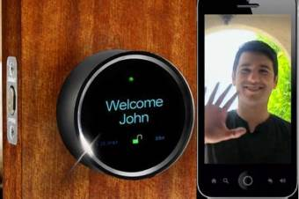
GOJI Smart Lock
It will not only get unlocked when it senses your smartphone near it, but will also greet you with your name. The entire things works through Bluetooth connectivity! Once you have the Goji smart lock installed on your door and a free app on your smartphone, you are all set to lock away your door of your room / cabinet / locker and keep your precious things safe from intruders. And when you are back, the lock senses your smartphone and unlocks the door automatically. And there's more. The Goji lock also has a built-in camera that takes pictures of all those who arrive. The lock connects to the home’s Wi-Fi connection and relays images and alerts to residents’ smartphones. So what if you end up losing you smartphone itself? Well you can cancel that particular phone’s access. All you need to do is cancel Goji access for your lost phone using Goji’s website or their 24-hour call center. You can cancel Goji access for your lost phone and request access to be transferred to another phone, effective immediately. You can regain control over your home access without changing or re-keying locks or worrying about anyone using your lost phone to gain access.



Voyce Band
Introducing a “smart” dog collar. It’s called VOYCE. (I was surprised it wasn’t called iSmart but there really are other folks as smart as the Apple ones!!) Created by a team of bio-medical engineers, veterinarians and dog behaviorists, the collar essentially tracks everything your dog is up to throughout the day. This includes all pertinent health data and, of course, info as to what that pooch put in its mouth. Since my best buddy is Pooky, my Shih Tzu, this was my favorite at CES.

While u catch ur breath with all that techno stuff, I’ll be putting together a new list of gee-wizzers, so stay tuned, but stay safe out there on the www.

Aloha, Lou



